# **Advanced Data Base Management**

Prashanth.S (19MID0020)

1. Draw EER diagram for the air e-ticketing software system.

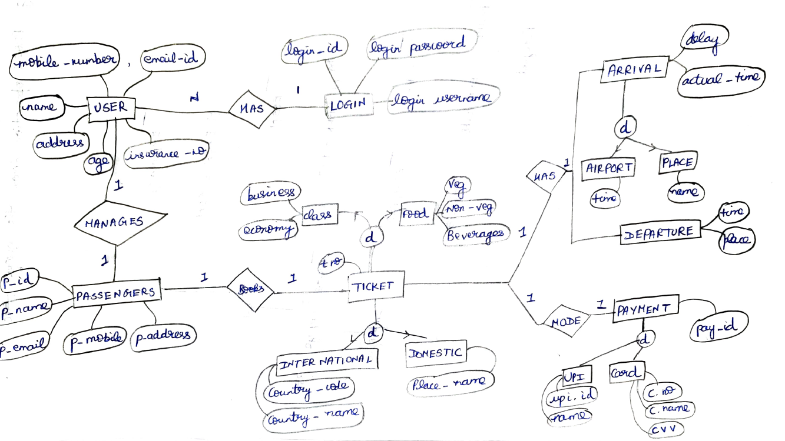

1. Elucidate the steps involved in processing the given high-level query.   
     
   Select Empsalary from employee, works, project where pname=”ERP_Auto” and Essn=ssn and pnumber=pno and empage > 35;

# **Initial (canonical) query tree.**

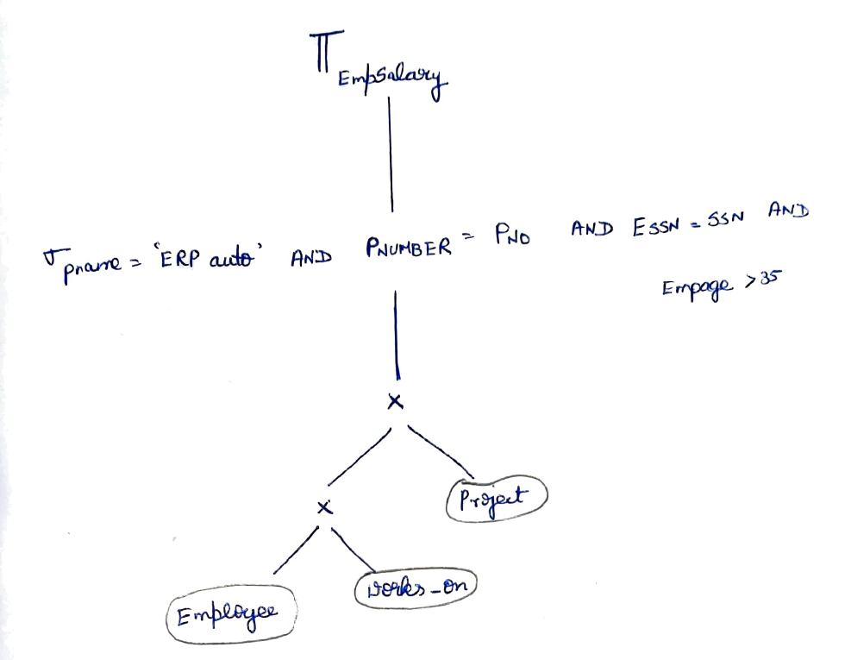

# **Moving the select operation down the query tree.**

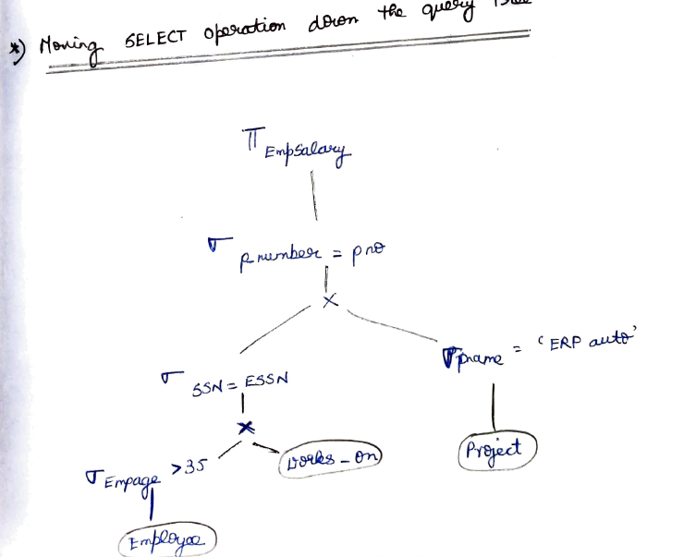

# **Applying more restrictive SELECT operation first.**

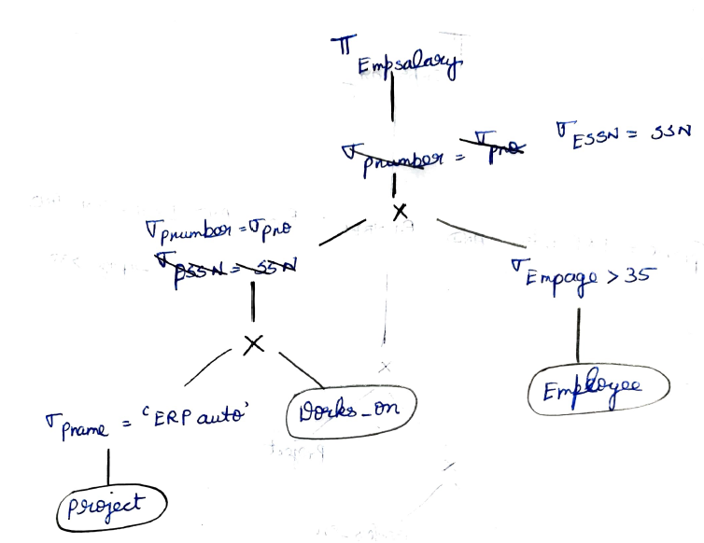

# **Replacing CARTESIAN PRODUCT and SELECT with JOIN operations.**

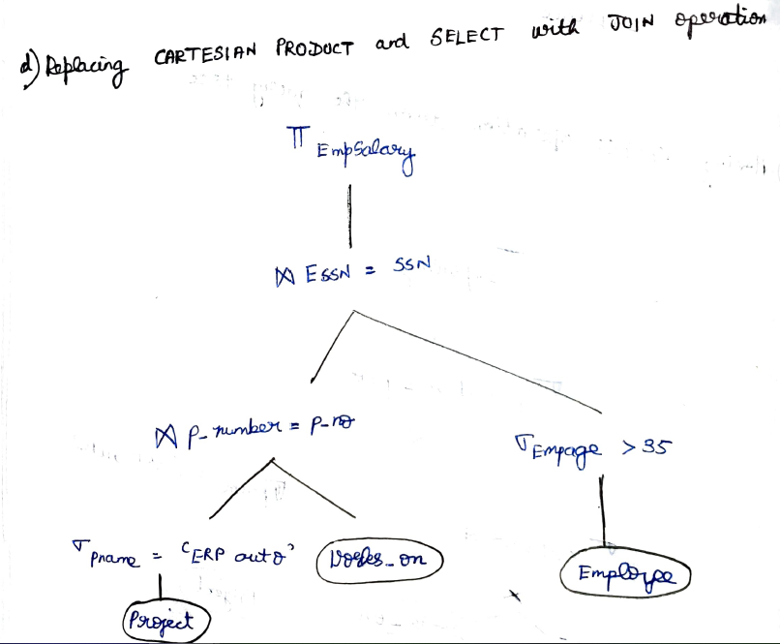

# **Moving PROJECT operations down the query tree.**

# 